**FOR IMMEDIATE RELEASE**

**Residents Urged to help PLAN Waterville by completing a Community Preferences Survey**

Waterville, Ohio – December 2024 – Waterville city leaders are requesting your help as part of the community planning process by taking the community preferences survey, the final survey in the process of framing the new Waterville Comprehensive Community Plan.

As part of the PLAN Waterville process that began in April, residents and students were able to complete surveys to help the steering committee identify broad planning themes and issues and opportunities to address. Nearly 700 residents, students, and other stakeholders have either completed the community survey or have been interviewed to date.

The 4 themes that emerged from the surveys are:

* Downtown and Neighborhood Revitalization
* Growth and Services Refinement
* Infrastructure and Utilities
* Connected Community

This “preferences survey” was developed to help the planning team and steering committee in framing strategies and tools for each of these areas. This preference survey can be completed by visiting the Waterville City website at [www.waterville.org](http://www.waterville.org) and clicking on Community Preferences Survey or by going directly to the survey at: <https://www.surveymonkey.com/r/WatervillePreferencesSurvey>

Waterville’s last comprehensive planning efforts were in 2012, and it was deemed time by community officials to develop a new vision for the future. For those residents that have not completed the initial community survey, there’s still time. A link to this brief survey can be found on the City of Waterville’s website under Important Alerts: Waterville Community Survey QR Code.

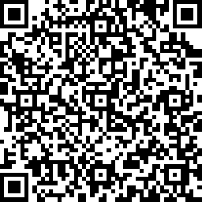Contact:

Jon Gochenour

Municipal Administrator

City of Waterville

25 N. Second Street

Waterville, Ohio 43566

(419) 878-8100

[jgoch@waterville.org](mailto:kknapp@ontarioohio.org)

#